**1. Write a C++ program to create object that has two fields: id and name. It creates instance of the class, initializes the object and prints the object value.**

#include<iostream>

using namespace std;

class student {

    public:

    string name;

    int id;

    void printInfo(){

        cout<<"Name is ";

        cout<<name<<endl;

        cout<<"ID is "<<id<<endl;

    }

};

int main()

{   student arr[2];

   for(int i=0;i<2;i++){

        cout<<"Enter Name ";

        cin>>arr[i].name;

        cout<<"Enter ID ";

        cin>>arr[i].id;

    }

    for(int i=0;i<2;i++){

        arr[i].printInfo();

    }

    return 0;

}

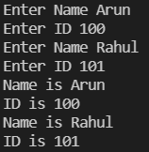

**2. Write a C++ program to initializing and displaying object through method.**

#include<iostream>

using namespace std;

class student {

    public:

    string name;

    int id;

    void printInfo(){

        cout<<"Name is ";

        cout<<name<<endl;

        cout<<"ID is "<<id<<endl;

    }

};

int main()

{   student arr[2];

   for(int i=0;i<2;i++){

        cout<<"Enter Name ";

        cin>>arr[i].name;

        cout<<"Enter ID ";

        cin>>arr[i].id;

    }

    for(int i=0;i<2;i++){

        arr[i].printInfo();

    }

    return 0;

}



**3. Write a C++ program with using the public and private in C++ Class.**

// C++ program to demonstrate private

// access modifier

#include <iostream>

using namespace std;

class Circle {

// private data member

private:

double radius;

// public member function

public:

void compute_area(double r)

{

// member function can access private

// data member radius

radius = r;

double area = 3.14 * radius * radius;

cout << "Radius is: " << radius << endl;

cout << "Area is: " << area;

}

};

// main function

int main()

{

// creating object of the class

Circle obj;

// trying to access private data member

// directly outside the class

obj.compute_area(1.5);

return 0;

}

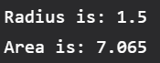

**4. Write a C++ Program to Implement a Class STUDENT having Following Members**

#include<iostream>

using namespace std;

class student {

public:

string name;

int roll;

int marks;

void topmarks(){

cout<<name<<" has got the highest marks"<<endl;

}

void highlow(){

cout<<marks<<" is the highest marks and "<<marks<<" is the lowest marks"<<endl;

}

void display(){

cout<<"Name is ";

cout<<name<<endl;

cout<<"Roll is "<<roll<<endl;

cout<<"Marks is "<<marks<<endl;

}

};

int main()

{ student arr[2];

for(int i=0;i<2;i++){

cout<<"Enter Name ";

cin>>arr[i].name;

cout<<"Enter Roll ";

cin>>arr[i].roll;

cout<< "Enter marks ";

cin>>arr[i].marks;

}

if(arr[0].marks>arr[1].marks)

arr[0].topmarks();

else

arr[1].topmarks();

if(arr[0].marks>arr[1].marks)

arr[0].highlow();

else

arr[1].highlow();

for(int i=0;i<2;i++){

arr[i].display();

}

return 0;

}

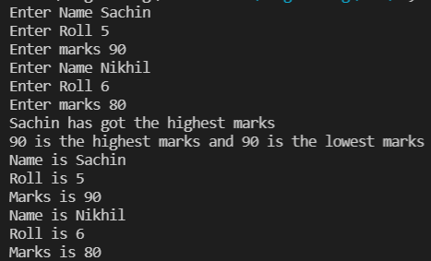

**5. Write a C++ Program to Calculate Electricity Bill of Person using Class.**

#include <iostream>

#include <conio.h>

using namespace std;

class EleBill

{

private:

int cur_Unit,pre_Unit,amt,unit;

//variable drclaration

public://function declaration as public

void get();

void printAmt();

};

void EleBill::get()//function definition

{

cout << "Enter previous unit:" << endl;

cin>>pre_Unit;//takes input from the user

cout << "Enter current unit:" << endl;

cin>>cur_Unit;//takes input from the user

}

/*1 - 100 = 1

101 - 200 = 2

201 - 300 = 3

above 300 - 5*/

void EleBill::printAmt()//function definition {

{

unit=cur_Unit-pre_Unit;

if(unit>0 && unit<=100)

{

amt=unit*1;

}

if(unit>100 && unit<=200)

{

amt=unit*2;

}

if(unit>200 && unit<=300)

{

amt=unit*3;

}

if(unit>300)

{

amt=unit*5;

}

cout << "Bill charge: " <<amt <<endl;

}

int main()

{

EleBill o;

o.get();

o.printAmt();

getch();

return 0;

}

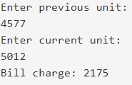

**6. Write a C++ Program to Calculate Simple Interest using class**

#include<iostream>

using namespace std;

class interest

{

int n;

float rate,p;

public:

void get()

{

cout<<"\nEnter principle Amount & no. of year: \n";

cin>>p>>n;

}

void cal(float rate)

{

float si;

si=(p*n*rate)/100;

cout<<"\n\nSimple Interest is: "<<si;

}

};

int main()

{

interest i;

i.get();

i.cal(4.5);

return 0;

}

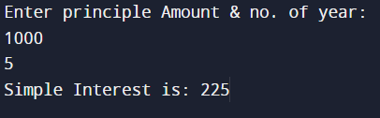

**8. Write a C++ Program to find Area of Rectangle using constructor.**

#include <iostream>

#include<math.h>

#define PI 3.141

using namespace std;

class AreaRectangle

{

private:

float area;

public:

AreaRectangle(float length, float breadth)

{

area = length * breadth;

}

void display()

{

cout << "Area:\t" << area << endl;

}

};

int main()

{

float length, breadth;

cout << "Enter the length:\t";

cin >> length;

cout << "Enter the breadth:\t";

cin >> breadth;

AreaRectangle area(length, breadth);

area.display();

return 0;

}

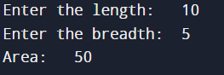

**9. Write a C++ Program to Display Date using Constructors**

#include<iostream>

using namespace std;

class date

{

private:

int dd, mm, yy;

public:

date()

{

dd=31;

mm=12;

yy=2016;

}

void display()

{

cout<<"\nThe Entered Date is ";

cout<<dd<<"-"<<mm<<"-"<<yy<<"\n";

}

};

int main ()

{

date date1;

date1.display ();

return 0;

}



**10. Write a Program to Generate Fibonacci Series use Constructor to Initialize the Data Members.**

#include<iostream>

using namespace std;

class fibonacci

{

long int a,b; //data members

public:

fibonacci() //special member function constructor

{

a=-1;

b=1;

}

void fibseries(int n) //member function

{

int i,next;

cout<<"\n Resultant fibonacci series\n";

for(i=0;i<n;i++)

{

next=a+b; //Expression

cout<<next<<endl; //To print the fibseries

a=b;

b=next;

}

}

};

int main()

{

fibonacci f;

int n;

cout<<"\n Fibonacci series \n";

cout<<"Enter the range = \n";

cin>>n;

f.fibseries(n);

return 0;

}

